**Improving Software Testing Processes**

**Introduction**

This report outlines a strategy to enhance the software testing processes within our company by identifying common bottlenecks, exploring current industry standards and technologies, and providing a practical example of unit testing. By implementing these improvements, we aim to increase efficiency, accuracy, and overall software quality.

**Step 1**

**Common Bottlenecks in Software Testing:**

1. **Lack of Automation**: Manual testing can be time-consuming and error-prone, leading to delays in the testing cycle.
2. **Insufficient Test Coverage**: Areas of the code may not be adequately tested, which can lead to undetected bugs in production.
3. **Inefficient Test Management**: Poor organization of test cases and results can lead to duplication of effort and missed test scenarios.
4. **Communication Gaps**: Lack of collaboration between development and testing teams can result in misaligned expectations and requirements.

**Areas for Improvement:**

* **Implement Test Automation Tools**: Adopting tools like Selenium or JUnit to automate repetitive testing tasks.
* **Increase Test Coverage**: Using coverage analysis tools to identify untested code paths and enhance test case creation.
* **Adopt Test Management Software**: Tools like Jira or TestRail can streamline test case management and reporting.
* **Foster Collaboration**: Regular meetings and integrated communication tools can bridge gaps between teams.

**Step 2:**

**Current Industry Standards:**

* **Test-Driven Development (TDD)**: Writing tests before code can ensure that requirements are met from the beginning.
* **Behaviour-Driven Development (BDD)**: Using plain language to describe the behaviour of the application can improve understanding among stakeholders.

**Technologies for Effective Testing:**

* **JUnit (Java)**: A popular framework for writing and running tests in Java applications.
* **MSTest/NUnit (C#)**: Frameworks for .NET applications that facilitate unit testing.

Practical Example: Unit Testing in Java with Junit

**Function to Test:**

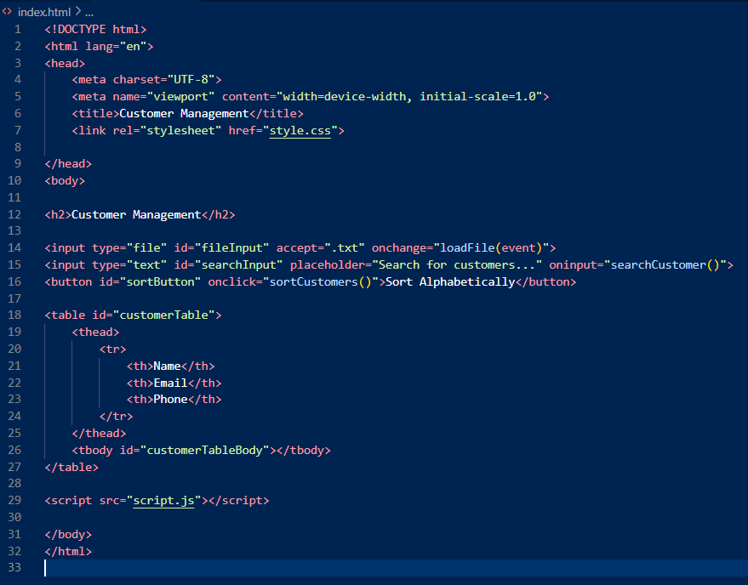

let customers = [];

function loadFile(event) {

    const file = event.target.files[0];

    if (!file) {

        console.error("No file selected.");

        return;

    }

    const reader = new FileReader();

    reader.onload = (e) => {

        const content = e.target.result;

        console.log("File content:", content);

        const lines = content.split('\n');

        customers = lines.map(line => {

            const [name, email, phone] = line.split(',');

            return { name: name ? name.trim() : "", email: email ? email.trim() : "", phone: phone ? phone.trim() : "" };

        }).filter(customer => customer.name);

        console.log("Parsed customers:", customers);

        displayCustomers(customers);

    };

    reader.readAsText(file);

}

function displayCustomers(customerList) {

    const tableBody = document.getElementById("customerTableBody");

    tableBody.innerHTML = "";

    customerList.forEach((customer) => {

        const row = document.createElement("tr");

        row.innerHTML = `

            <td>${customer.name}</td>

            <td>${customer.email}</td>

            <td>${customer.phon>

        `;

        tableBody.appendChild(row);

    });

}

function sortCustomers() {

    console.log("Sorting customers...");

    customers.sort((a, b) => a.name.localeCompare(b.name));

    displayCustomers(customers.filter(customer =>

        customer.name.toLowerCase().includes(searchTerm)

    );

    console.log("Filtere

        row.innerHTML = `

            <td>${customer.name}</td>

            <td>${customer.email}</td>

            <td>${customer.phone}</td>

        `;

        tableBody.appendChild(row);

    });

}

function sortCustomers() {

    console.log("Sorting customers...");

    customers.sort((a, b) => a.name.localeCompare(b.name));

    displayCustomers(customers);

}

function searchCustomer() {

    const searchTerm = document.getElementById("searchInput").value.toLowerCase();

    console.log("Searching for:", searchTerm);

    const filteredCustomers = customers.filter(customer =>

        customer.name.toLowerCase().includes(searchTerm)

    );

    console.log("Filtered Customers:", filteredCustomers);

    displayCustomers(filteredCustomers);

}

if (typeof module !== 'undefined') {

    module.exports = { loadFile, displayCustomers, sortCustomers, searchCustomer, customers };

}

Test Script

**Step 3:**

**Using Current Technologies:**

* **Continuous Integration (CI)**: Integrate unit tests into a CI pipeline (e.g., using Jenkins or GitHub Actions) to run tests automatically upon code commits, ensuring rapid feedback.
* **Code Coverage Tools**: Use tools like JaCoCo to analyze code coverage and ensure that tests cover critical paths in the application.

**Running the Test:**

**Conclusion**

By implementing these improvements, including automating testing processes, increasing test coverage, and fostering better communication, we can significantly enhance the software testing practices in our company. The example provided demonstrates how unit testing can be effectively utilized to ensure code quality.

PS C:\Users\User\Documents\GitHub\CustomerManagement> npm run test  
> customermanagement@1.0.0 test  
> jest  
  
 console.log  
Sorting customers...

at log (script.js:42:13)

console.log

Searching for: alice

at log (script.js:49:13)

console.log

Filtered Customers: []

at log (script.js:53:13)

FAIL ./script.test.js

Customer Management Tests

× Sort customers alphabetically (34 ms)

× Search for a customer by name (15 ms)

● Customer Management Tests › Sort customers alphabetically

expect(received).toBe(expected) // Object.is equality

Expected: "Alice Smith"

Received: "Bob Johnson"

18 | ];

19 | sortCustomers();

> 20 | expect(window.customers[0].name).toBe("Alice Smith");

21 | expect(window.customers[1].name).toBe("Bob Johnson");

22 | });

23 |

at Object.toBe (script.test.js:20:42)

● Customer Management Tests › Search for a customer by name

expect(received).toContain(expected) // indexOf

Expected substring: "Alice Smith"

Received string: ""

35 | const tableBody = document.getElementById("customerTableBody");

> 36 | expect(tableBody.innerHTML).toContain("Alice Smith");

37 | expect(tableBody.innerHTML).not.toContain("Bob Johnson");

38 | });

39 | });

at Object.toContain (script.test.js:36:37)

Test Suites: 1 failed, 1 total  
Tests: 2 failed, 2 total  
Snapshots: 0 total  
Time: 1.169 s  
Ran all test suites.